**Be Part of Spirit of a Forester Scholarship Competition Day**

**A Great Community Engagement Experience**

**Dear Faculty and Staff,**

As we approach the fall, we’re gearing up for an exciting ***Spirit of a Forester Scholarship Competition event for prospective students o*n October 18th and 19th**, and we’d love for you to be part of it. Specifically, we’re looking for your friendly and supportive personality to help interview our exceptional prospective admitted students on **Saturday, October 19th from 9:30 AM to 12:30 PM.** Whether you can commit to the full morning or just part of it, your involvement will make a meaningful impact on their decision to join our HU community.

**Here’s why you’ll want to get involved:**

* **Engage with Talented Students**: Experience firsthand the passion and potential of the next generation of Foresters.
* **Shape Futures:** Your guidance during interviews can help these students envision their future at HU.
* **Be Energized:** The day will be filled with inspiring stories, meaningful connections, and the excitement of helping students take the next step in their journey.

**Event Highlights:**

* **What:** Our admitted students will compete in the *Spirit of a Forester Scholarship Competition* with a welcome appreciation dinner on Friday, October 18th and competition on Saturday the 19th. On the 19th, students will participate in interviews, write essays, and showcase their Forester spirit for a chance to earn significant scholarships.
* **Who:** You’ll be paired with another faculty or staff member to conduct interviews.
* **When:** Saturday, October 19th, from 9:30 AM to 12:30 PM. If you can’t commit to the entire time, you can join us for 9:30 AM – 11:00 AM or 11:00 AM - 12:30 PM. Each interview will last about 15-20 minutes.
* **Where**: The interviews will be held in the Dowden Science Building, with six interview rooms running simultaneously.
* **How:** We’ll provide a list of interview questions and a rubric to guide the process.

This is a unique opportunity to showcase what makes HU special and to help our brightest prospects choose us. Let’s make this day unforgettable – [sign up now](https://huforms.formstack.com/forms/spirit_of_the_forester_faculty_staff_rsvp) and join the experience!

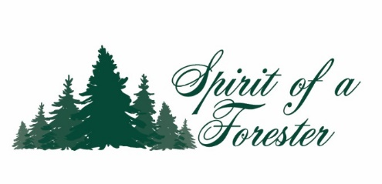

If you have any questions, I’m here to help. We look forward to having you with us!

Susie Carr  
[scarr@huntington.edu](mailto:scarr@huntington.edu)