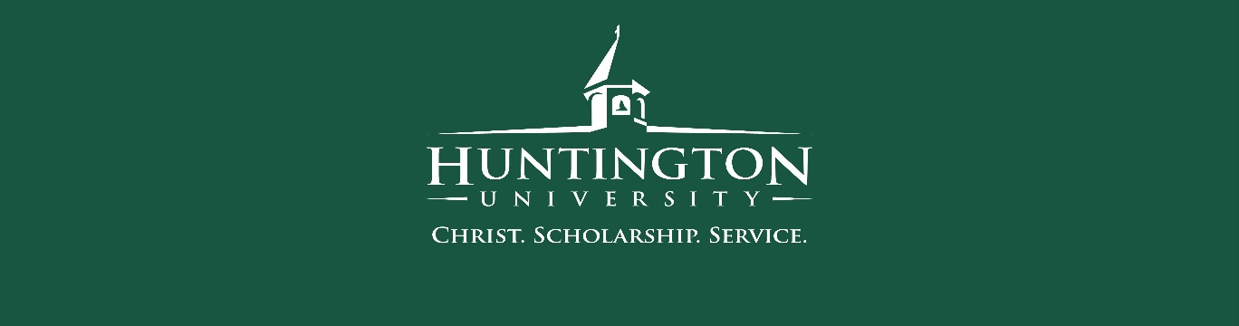
Huntington University – Office of Admissions
Appreciation Award
March 2024

Recognition: Barb Michel, EdD – Professor of Art / Chair, Department of Art & Design
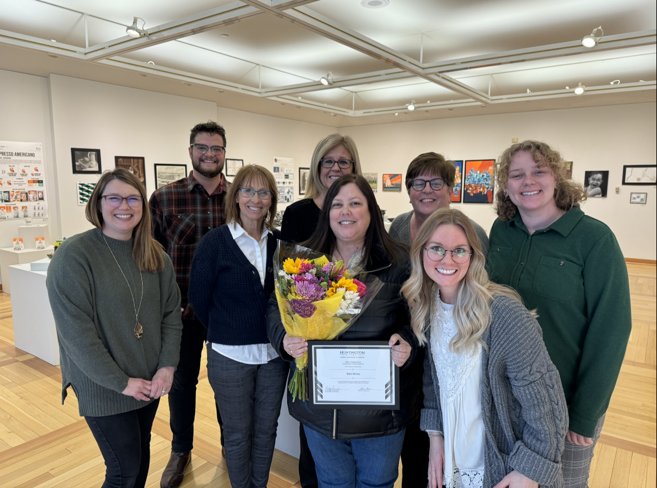

I'm thrilled to share that Barb Michel has been selected for the March 2024 Office of Admissions Monthly Recognition Award. Barb's remarkable communication skills and unwavering dedication have made a profound impact on student experiences within the Art & Design Department and Admissions. Her commitment to excellence shines through in every interaction with our department and students. Her efforts have significantly elevated the reputation and influence of our university. Congratulations, Barb, on this well-deserved recognition! Let's continue to celebrate the achievements of our exceptional team members as we work together towards our shared goals.

Susie Carr
Director of Admissions
Office of Admissions

