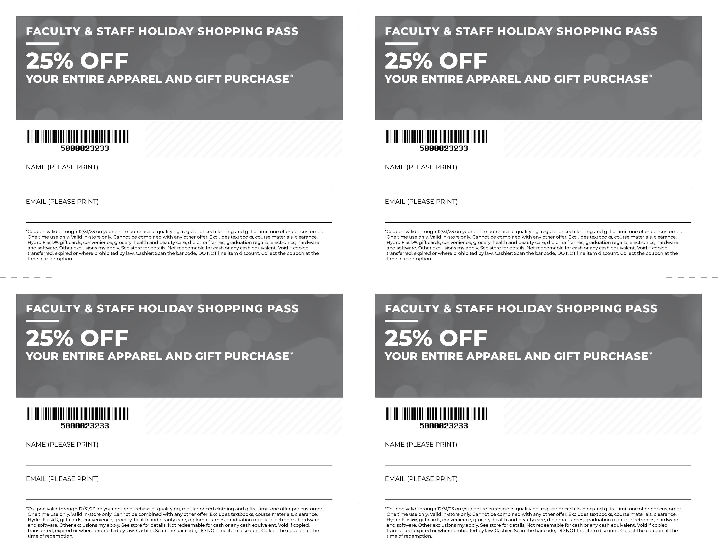

Huntington University / HuntingtonBookstore.com

Huntington University / HuntingtonBookstore.com

Huntington University / HuntingtonBookstore.com

Huntington University / HuntingtonBookstore.com