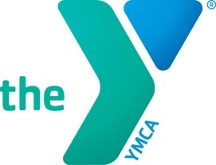

CORPORATE MEMBERSHIP

PAYROLL DEDUCTION

EMPLOYER: ______Huntington University___________________________________________

EMPLOYEE: ____________________________________________________________________

MEMBERSHIP TYPE: ___________________________ EFFECTIVE DATE: ___________________

|  |  |  |  |  |
| --- | --- | --- | --- | --- |
| Membership  Types | Payroll  Deduct  Enrollment  Fee | Regular  Rate  (monthly) | Corporate  Partner  Employee  Rate | Check  Membership  Type  Requested |
| Household | $37.50 | $63 | $58 |  |
| Adult | $37.50 | $41 | $38 |  |
| Single  Parent  Household | $37.50 | $45 | $42 |  |

*All Rates Are Subject to Change*

As a corporate member, I agree to allow my employer to withdraw the specified rates through payroll deduction in conjunction with all payroll policies and procedures. I understand it is my responsibility to inform my employer and the YMCA if I wish to terminate my membership at any time and pay any outstanding fees directly to the YMCA for past membership months or classes previously attended prior to my membership termination.

Employee Signature ______________________________________ Date _______________

Employer Signature ______________________________________ Date ________________

(Original to HR, copy to YMCA to start the membership process)